

**University of Ontario Institute of Technology**

**Faculty of Engineering and Applied Science**

**Lab #3: Uber Rush Project**

**Date: Mar.18.2019**

|  |  |
| --- | --- |
| **Name** | **Student ID** |
| **Yin Zhou** | **100314426** |
| **Jana Kanagalingam** | **100603975** |

1. Since Uber’s development team have developed similar applications in the past with Uber and UberEats, the development team have experience and similar models to assist in building the new app in a reasonable amount of time. In addition, the goal and requirements are well defined thus an organic approach can be used.

The estimation using COCOMO with organic project will result of formula as following:

Formula:

E = 3.2*(KLOC)^1.05

D = 2.5 * E^0.38

The software architecture will closely resemble VIPER (view,interactor, presenter, entity, and router) pattern. From the past experience, the Uber app had about 428K LOC for android app and 720K LOC for iOS app which in total is about 1150 KLOC. Yet, as a new development with very similar function owned by the company, most of the code can be technically transferred and estimated new line of code will be only about 10% of total code. Hence, the actual new line of code will be 40 KLOC and 70 KLOC

|  |  |  |
| --- | --- | --- |
| Team | Effort (person-month) | Duration |
| Android (40 KLOC) | 154 | 17 month |
| iOS (70 KLOC) | 278 | 22 month |

Two separate teams will be working on one platform.

2. Activity diagram is shown below

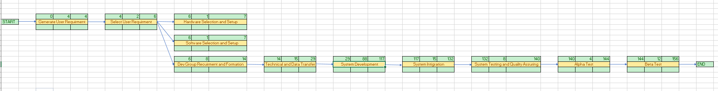

**3.**

|  |  |
| --- | --- |
| **Risk** | **Risk Reduction Techniques** |
| **Drivers with criminal history** | Have a background screening, no history of assault,theft etc in the past and also have packages covered by insurance for up to $100 if lost by driver. |
| **Bad drivers** | Have drivers provide a clean drivers abstract. |
| **Car accidents** | Drivers who get into accidents will be covered by the company’s (Uber’s) insurance when they are actively on the job with the app running, following the same approach as Uber and UberEats. |
| **Damaged goods during delivery** | There will be terms and conditions that drivers have to agree to, which states that drivers must cautiously handle packages when dealing with deliveries. Drivers must inspect packages to ensure no signs of visible damage. Both the driver and the employee giving the package to the driver must sign off on the package not being damaged through the app before the delivery is made. Any items found to be damaged/defected by the customers is then dealt between the consumer and the store, not UberRush. Packages damaged by the UberRush driver will be covered by the company’s insurance,anything higher than $100 will be the responsibility of the driver to cover. |
| **Risk of security breaches** | Developers should protect app code with encryption. You want the code to be secret, and hard to read. Test code for vulnerabilities |
| **Not meeting time/cost estimates** | Analyze past projects like Uber/UberEats. Cost estimation model and expert judgement will assist in meeting deadlines and estimations. |
| **Performance problems during app deployment** | Prototyping and simulations will help in testing out the app while fixing any issues that may arise. |
| **Inexperienced app developers** | Make sure developers/engineers are highly qualified by looking at their credentials and have a standard coding test that each person must do during the hiring process. |